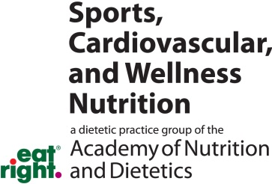

SCAN Web-Based Self-Study
Continuing Professional Education Q&A

Title: How to Present Like a Pro in a Healthy Cooking Demo

Presenter: Tori Ritchie
NOTE: This sheet must be submitted no later than May 31, 2013
CPE credit will not be awarded for submissions received after this date.
Number of credits awarded: 1 CPEU, Level 1

Please complete the information below, answer the questions, and e-mail to: scandpg@gmail.com
(Be sure to write Web Self-Study CPEU in the Subject line)

Your full name: _______________________________________________________________
Your ADA membership number: ____________________________________________

As an alternative, you may mail this to SCAN/Digestive HealthWorks, LLC, Sara Estrella, Administrative Assistant, 1520 Kensington Rd., Suite 202, Oak Brook, IL 60523

Instructions: Place an X next to the best answer or answers to each question below.
Note: More than one answer may be correct for any question.

1. In January you are shopping for the 15 ingredients you need for your upcoming TV demonstration. You decide to change your recipe because:
- The ingredients are not in season
- There are too many ingredients
- You are not sure the audience will like it
- It is not as healthy as you originally thought

2. While doing your demonstration you drop your utensil. You Should:
- Apologize profusely to the audience
- Smile and make a joke
- Use a different utensil and continue
- Panic

3. Which of the following is recommended attire for your demonstration
- Your best outfit and shoes
- Bright patterns or strips
- Solid colors like blue or brown
- Long sleeves

4. While doing a demonstration which of the following is NOT recommended
- Using talking points
- Demonstrating portion control
- Periods of silence while demonstrating
- Giving suggestions for sodium substitutes

5. At the end of your demonstration you have thanked the audience and your sponsors and asked if there are any questions. No one speaks. You should:
- Thank them again and end your demonstration
- Keep asking until someone asks a question
- Keep talking
- Ask the audience a question they might want to know

6. When asked to do a demonstration which of the following is not recommended:
- Check the venue personally
- Choose a simple nutritious recipe
- Practice your demonstration multiple times
- Choose a complicated recipe to highlight your cooking skills.

7. The 4 basic tenants of a good demonstration recipe are
- Simple, Versatile, Manageable, Yummy
- Complex, Versatile, Manageable, Yummy
- Complex, limited, Healthy, Yummy
- Simple, limited, Manageable, Yummy

Answer Key
1. 2
2. 3
3. 3
4. 3
5. 4
6. 4
7. 1

